

FACULTY OF TECHNOLOGY AND ENGINEERING
DEVANG PATEL INSTITUTE OF ADVANCED TECHNOLOGY AND RESEARCH

DEPARTMENT OF INFORMATION TECHNOLOGY

A.Y 2026-27 Semester-3

LAB MANUAL

CSUC201: Fundamentals of Data Structure and Algorithms



Practical 7
Practical AIM:
To implement queue using array and linked list, and apply queue-based logic to number generation, and structure simulation problems.
Practical 7.1
Problem definition:
A government office has a token counter that issues tokens to visitors. The counter can hold at most n tokens at a time. New visitors join from one end and are served from the other end in the order they arrived. If the counter is full, no new token can be issued, and if it is empty, no one can be served. Given a sequence of join and serve operations, implement this fixed-capacity token system and print the current front token after each operation. Report an error if an operation cannot be performed.
Describe how your solution tracks the front and rear of the queue. What happens to your front and rear pointers over time as join and serve operations keep happening, and does your solution handle the case where space appears to run out even though slots have been freed?
Problem faced:
I faced difficulty in managing the front and rear positions and handling the full and empty conditions of the queue.
Solution:
I used front and rear variables to track the queue. I checked whether the queue was full before joining and empty before serving. I also used circular movement to reuse the freed spaces.
Output:
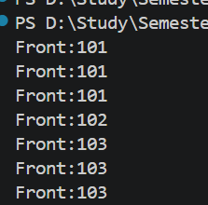
Practical 7.2
Problem definition:
A hospital emergency ward receives patients continuously and attends to them strictly in the order they arrived, with no upper limit on how many can be waiting at once. New patients are added at the back and the doctor always attends to the patient at the front. Given a sequence of arrive and attend operations, implement this unlimited patient queue and print the current front patient after each operation.
Describe how your solution differs from Problem 1 in how it manages capacity. What happens in your solution when the attend operation is called on an empty ward with no patients waiting?
Problem faced:
I faced difficulty in managing the queue dynamically and handling the attend operation when the queue was empty.
Solution:
I used a linked list so the queue can grow dynamically without a fixed size. I used front and rear pointers to add and remove patients. If the queue was empty, I displayed an error message.
Output:
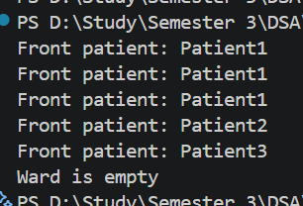
Key Questions
1. [Problem 1] A simple array queue eventually reports being full even when slots have been freed at the front. Explain why this happens structurally — not by tracing an example, but by describing what the front and rear pointers represent and what their movement pattern causes over time.
ANS:
In a simple array queue, front points to the first element and rear points to the last element. When elements are removed, front moves forward, but rear continues moving forward when new elements are added. Therefore, the empty spaces at the front cannot be reused, and the queue may become full even though some spaces are free.
2. [Problem 2] Your linked list queue has no capacity limit. If arrive operations vastly outnumber attend operations over a long period, what real consequence would this have on the system, and where in your code is that consequence invisible?
ANS:
If arrive operations happen much more than attend operations, the linked list keeps growing and uses more memory. If this continues for a long time, the system may run out of memory. This is not visible in the code because new Node keeps creating new nodes without any capacity limit.

Github link:
https://github.com/dhanvi-219/FDSA/tree/main/Practical%207

